Divine, don’t gamble
----Deconstruction & Review of Persona 4 Golden (PS vita)

Persona Game Series is a famous JRPG game series, which used to be a branch series from Megami Tensei, has now become one of the most successful series of JRPG. Persona 4 Golden (abbreviate as P4G) is a remastered PSV version of the PS2 game Persona 4. This game is a successful iteration of the Persona Series. The Persona Series has considered to be a revolution of JRPG games. This game combine Carl Gustav Jung’s psychological theory of collective unconscious with Tarot, a traditional European divining method and the Myth Characters from different civilization (e.g. Jewish Myths, North European Myths, Fairy Tales, Japanese Myths). Due to the fashion art style, this game is also famous among many western players
This game has a fascinating storyline. Nevertheless, the gameplay is a more important part which make this game outstanding. I will try to omit the storyline and focus on the gameplay deconstruction.

Core Loops
Basically, like any other JRPG games, the game loop is about: Upgrading/Maze Exploring -> Boss Fighting. -> Storyline Continuing. And the whole picture of the game’s playing pattern is somehow a 3-layer loop: Basic Battle Loop, Daily Life Loop, Storyline Loop. I want to including Storyline Loop because it’s not a soft connection between events, but more like a structure of multiple events which is closely integrated with Character Building.
Basic Battle Loop
The battle is a turn-based gameplay. Like many other turn-based RPG games, players need to make choices between Attack, Defense, Escape, Using Items/Skills. What makes this game interesting is the “one more turn” mechanism. When the character deals a critical attack, or using the right damaging skill to enemies’ weakness, player will gain another special round to operate, and enemy will be knocked down, with operation sequence initiated. And enemies can do the same to players. Because of this mechanism, players can win the battle with superior advantage with proper strategy. Meanwhile they need to avoid being knocked down when the enemy is stronger.
The weakness system is designed with 7 independent attributes: Physical, Flame, Ice, Wind, Thunder, Light, Darkness. Every unit in the game has 5 states for each attribute: Reflect (Reflect damage of this attribute), Immune (Receive no damage of this attribute), Strong (Receive less damage of this attribute), Neutral (Receive standard damage of this attribute), Weak (Weak to this attribute).

Normally, turn-based RPG games are more about repeating steps of strategies, which makes players feel boring comparing with real-time games. A safe way to improve players experience is to reinforce character building mechanism to equip the game with more retention mechanism, which is applied in many mobile RPG games. Another approach is adding some supportive mechanism to gain dramatic advantage (e.g. freeze, weaken etc.) and tune the numerical value to create tense battle. Besides, many studios simply turn to real-time RPG games development. P4G’s idea here is that except tune the numerical values to increase the gap between advantage and disadvantage, use a generalized mechanism that every unit have the potential to reverse the advantage or disadvantage. And with this “one more turn” mechanism, the gameplay is in fact tense enough, even when players are fighting low-level troops in the mazes. For example, the Light & Darkness are two attribute associated with instant-kill skills. Even some low-level troops can use such a skill. On the other hand, players can use such skills to achieve much faster battle process. As for the boss battle, attacking the weakness is even more crucial.
To optimize the gameplay experience, the attribute of a new enemy is hidden, players need to deal attempt attack to get the information of the weakness. Then “one more turn” mechanism is capable to create quite a lot of uncertainty when player encounter new challenge. And after they learn about the patterns, those uncertainties quickly transform into their strategy skill. Further gameplay will be the combination of different attribute bias, which is connected tightly to character building system. Also, the combination of different enemies can create more challenges, even the enemies are low-level troops.
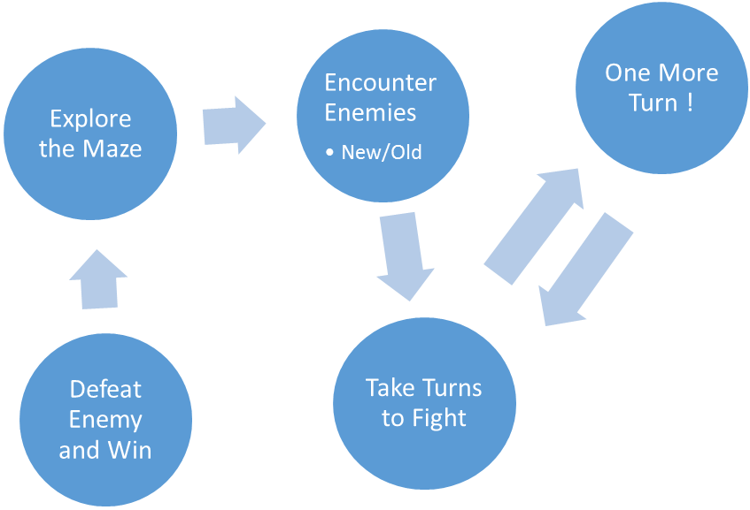
Daily Life Loop
This loop can be considered as the intermediate layer of the whole game. It contains three actions: Developing Personality, Developing Community, Developing Persona Ability.
First we need to introduce the core of the game, Persona. Persona is the meta-mechanism of this game. It can be basically considered as a character building system. Because characters’ abilities are defined as the ability of their persona. Persona is a game-specified concept. It is from Jung’s psychological theory, basically meaning a kind of personality style. Persona can be upgraded and reinforced. Players can change their persona during the battle to deal with different situations. While for player’s companions, their persona cannot be changed but can be upgraded. Player need to upgrade personas separately. Basically, you can consider persona is like hero card in many mobile RPG games.
Persona can be collected in 2 ways:
- Battle Reward
- Persona Fusion
Normally battle rewarded persona is trivial. To get more powerful persona, players need to fuse by themselves. And to fuse high-level persona, players need to increase their Commu level. Commu is another important concept of this game, basically as an abbreviation of community. Commu means player’s closeness with other characters in the game. In P4G, personas are classified into several Tarot terms, like The Fool, The Magician, The Emperor. Different classes of personas have different patterns of ability. Each class is represented by a character in the game. Characters varies from player’s closest companions to some sub-mission NPC. Normally, to upgrade the Commu level, player need to experience a short story line of this character. And some story lines are forced to experience as the main story.
Another system associated with the Persona and Commu system is the Personality (please don’t mistake with Persona). Personality is the attribute of player’s own avatar’s attribute, like courage, wisdom, etc. As I mentioned, Commu level is upgraded with some story line. To trigger these story line, player’s avatar requires some specific personality, like the courage to be a daredevil.
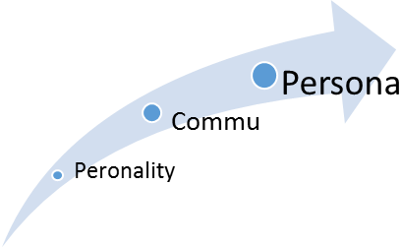
Then we may come to the Daily Life Loop. The game process is not pushed by a series of mission. Instead it’s more like the repeating 24-7 real life. Everyday player needs to choose between 3 actions: Develop Personality, Develop Commu, Maze Exploring (can be regarded as Develop Persona). Some actions are compulsory, some are optional. There are very few choices in a single day. It’s like if you want to go to maze, you’ll have to time to spend with your companion and vice versa. The daily time is basically divided into day and night, meaning 2 options in a loop. Here we may refer to the Daily Life Loop as following:
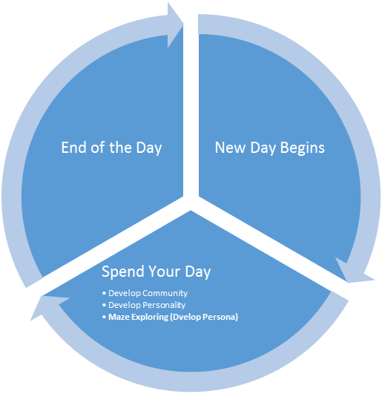

Strictly speaking, this cannot be considered as a traditional mission-driven loop in many RPG games. However, there’s no doubt that this is the main gameplaying loop in the game. In fact, the time devoted to each action is dramatically biased. As for the Community and Personality related actions, details are omitted. You just read some dialogue and time is gone. In comparison, the Maze Exploring is much longer; you need to spend maybe hours to battle and explore. However Daily Life Loop doesn’t flow during this process. It’s like an abnormal world in many mysterious novels when players are outcast from reality. So, the actual gameplay dynamic is more like a double life experience that players have between reality and abnormal world. They encounter victim events in daily life and settle them in abnormal world.
Storyline Loop
Since I mentioned the double life of player’s avatar. I’ll go through the Storyline Loop here to complete the game process mechanism. Basically, the storyline is about rescuing people who are in danger, then befriend with them, and finally they become your companions. As I stated, the Persona system is largely based on the closeness of player’s avatar with the game characters. So, the choices in Daily Life Loop will determine the Persona that players can use in battle. I think what is fascinating of this game is that story line and battle system are organically integrated under a modern theme, psychology. (Maybe fans should thank Jung’s psychological theory here because it somehow connects the adventure nature in those myths with people’ psychological activities in modern life.)
Strictly speaking, the Daily Life Loop is a free and undisciplined gameplay style. On the contrary, the battle in abnormal world is rather tense. How to tune the experience for players will rely on Storyline Loop. P4G’s idea is using a deadline for the rescuing action. Players can feel free to make their rescuing plan in the abnormal world only if they can rescue successfully before the deadline date. Players may choose to spend much more time in Daily Life Wandering and events with other characters, familiar with their stories and grow bound with them. On the other hand, they can also focus on the battle more and enjoy the winning. The tradeoff is that if player choose more daily life, they might miss the deadline and game is over. And if they choose abnormal world, their closeness with other characters won’t increase and the power of their persona will be weak.
In P4G, there is no save point or recover point inside the maze. Instead, player will start from the floor where they left the maze if they recover and re-enter. Whenever player is going to reach the final boss of the maze. Normally players will have a harder battle if they confront boss right now. And companions will suggest players retreat and prepare for the battle next time. With the help of this detail design. The whole dynamic milestone loop will be like this (but it may vary depending on players, the 4th and 5th stage can be merged):
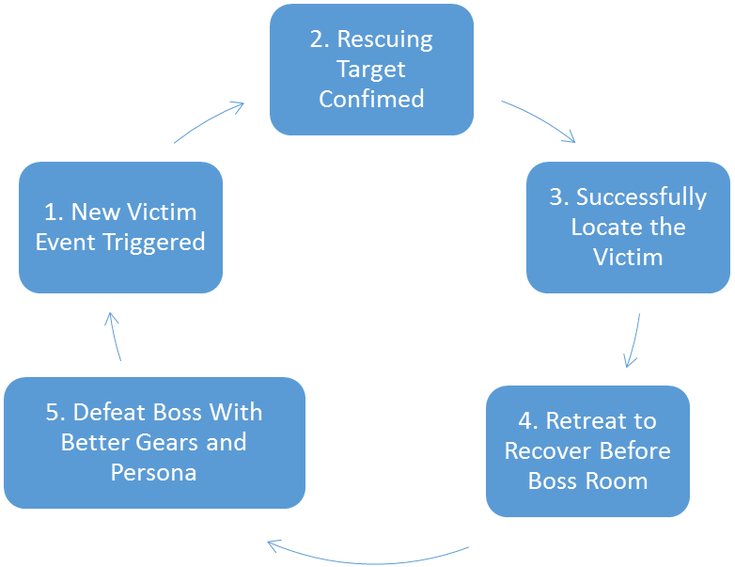
The connection between these milestones are either daily life or maze exploring. So, in this game, there is no clarified mission (quest) system as many other RPG games do. Instead the whole game is processing in the pace of daily activities. And the result of each choice will be revealed later. For this mechanism, we may evaluate the pros and cons:
The pros are:
- It is easier to hide some interesting game contents for players to discover.
- Help create a more immersive experience in the game.
- Strengthen the emotional reactions of players in those turning points of story scripts.
The cons are:
- Player must make more blind choices, which might make them feel depressed if the choice turn out to be bad.
- Players may quit early because the story goes slow at the beginning.
Overall, the whole mechanism of P4G can be described as a 3-layer gameplay:
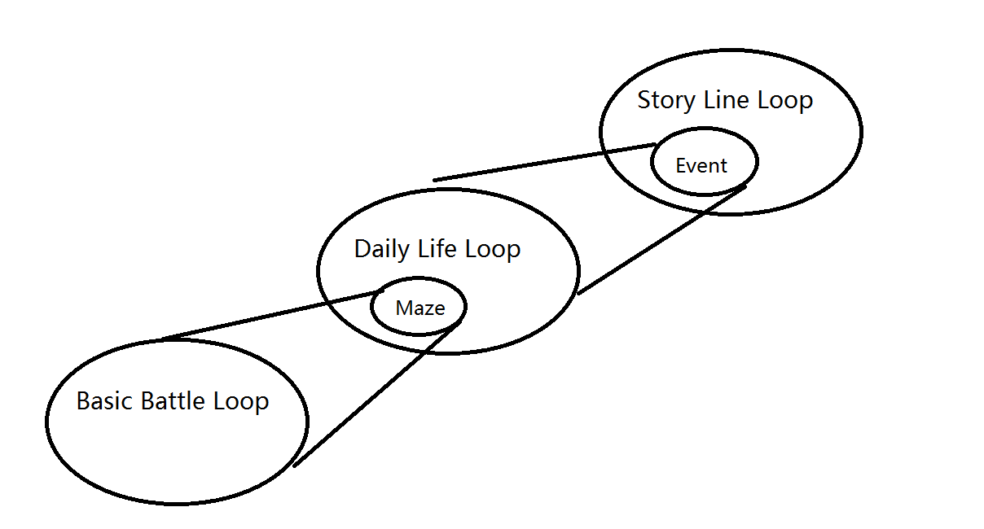
Retention
We need to first admit that P4G is not a free-to-play game. So, for the retention part, (similar for social and monetization part) it may not be analyzed like how we see a mobile game. And considering that story usually plays an important role in keeping players stay in game world in RPG games, the story script somehow is even more important than gameplay mechanism for retention purpose. Even though P4G has a good story, its retention mechanism is still a well-structured system. Many players review that they spend hundred hours in this game. The game studio also claims the game to have almost 70 hours to complete.
I think P4G has two core retention mechanism: Battle Reward & Persona Fusion. These two mechanism have one thing in common: a balanced gameplay between uncertainty and strategy. Battle Reward is a support system while Persona Fusion is a core mechanism. These two system supports the main game loop and provide different fun aside from the battle and story.
Battle Reward
The battle reward of P4G more like a mini game rather than a return list after winning. It is not a very complex system. Basically, it is made up of 52 cards from Tarot and all the Persona & Skill cards. The mechanism of the battle reward is that:
- Several cards with special functions are presented to the player.
- Player draw one from these cards.
- The function of the card will take effect.
- If the function involves redrawing, player will back to the first step again. If not, settle the reward.
Normally, there are 3-5 cards after each battle. The functions of these cards are buff/debuff, card shuffle, reward tradeoff. Many of these cards will take effect in the next battle or even the whole floor in the maze. Thus, this mechanism somehow encourages players to try another battle because normally they don’t want to waste the buff. Another influence of this mechanism is tuning. Because in P4G, player can’t save games inside the maze. They must carefully balance their characters’ states. For example, one frequent buff is life/mega recovery. If player made a mistake in the battle and need some recovery, they certainly tends to choose Recover. Such behavior did create more choices for players.
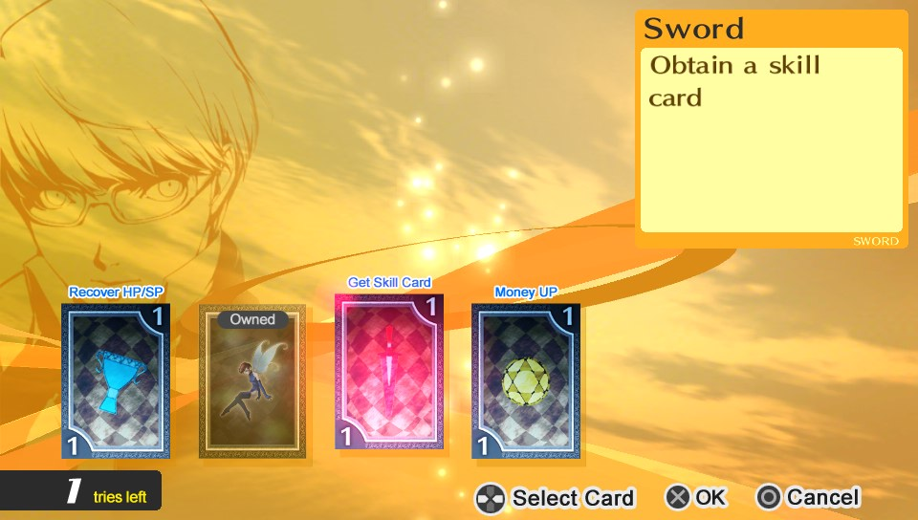
This mechanism softens the maze exploring process. As players have more choices, they will spend more time on the balancing. At mean time, the cards are shuffled, which means players cannot choose the initial cards. The gameplay is more like a divine. There is a balance between certainty and uncertainty. How the situation is generated is completely obscure. But how to perceive the situation and strategy is player’s choice. Comparatively speaking, gambling is different. It is a direct path from chance to result. There is little that players can do to optimize the outcome. Gambling has its own style of gameplay in many games. Its more exciting and needs less concerning. But divining creates a substitute gameplay where players feel they are capable to handle the situation. Meanwhile there are some tense and exciting moments as results of their decisions.
Persona Fusion
Persona fusion is another core mechanism associated with main loop of this game. It is a much more complex system in this game. And thanks to the complexity, players did spend much more time on this game. Besides what I mentioned in the Daily Life Loop part. The actual fusion system is more than a simple summoning ritual.
To fuse a Persona, player needs some other personas as sacrifices. And the new persona will inherit ingredients’ skills. Though the weakness attribute is pre-defined. What matters is that this system is not a straight up system. There are chances that some powerful personas fuse a weak one. The mechanism behind that is the formula of Tarot classes. For example: The Fool + The Empress = The Moon. There is a picture to illustrate.
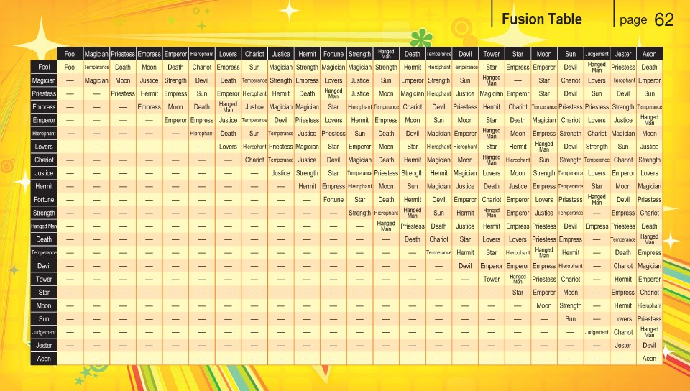
We can see this is a rather complex system. For each class of Persona, there are about 7-10 units. All units in a class are ranked by the level. The formula only determines the class. The level is determined by ingredient Personas.
In practice, players only know what they can get based on their current inventory. And they can carry a limited number of Personas. This fusion table is not shown to players, which make the system even harder to perceive. Thus, player probably can’t memorize all the combinations. They will use the formula or just randomly fuse.
At the early periods in the game, Persona fusion is not very important because players can win easily. Players will have no clues of how to fuse the best Persona. However, such many combinations guarantee that players can fuse better Persona than what they have right now. At the later periods of the game, players will gradually get familiar with the system and think more about fusing a better Persona. When they started to learn about the formulas through the web or other way, the system become less obscure. They will fuse some powerful units on purpose. However, because they lack the inventory to store large number of Personas. They will explore the maze again to get ingredients. Normally they can’t get the best Persona in their first complete game process. Then the eager for the best one becomes their motivation to play the game again. And this time, they will be able to carefully choose the ingredients. And they may even find their own fusion path based on the formulas.
Still this system is another divining gameplay as I mentioned. The rules of fusion are obscure at the beginning. But players can still make some good choices in this period. Then after they are familiar with the system. They still can’t fuse whatever they want. But with proper choices, they can still get what they want without too many attempts. The whole process doesn’t require much luck. What players need to do is just pick the best choice from what are given to them.
As a console game, P4G is not designed for endless playing as in many F2P games. Thus, the replay of the game will be the purpose of retention. Except for the Battle Reward and Persona Fusion. There are some hidden contents like hidden boss fight only unlocked in the second-round playing. Since these idea is no different from many other games, I’ll just mention here.

Social
As a remastered work, P4G add some current popular network gameplay. Strictly speaking, these are just some anonymous interactions. It might be hard to consider these mechanisms as social gameplay. The network gameplay is called “voice”.
Viewing others’ choices
When players don’t know what actions to choose in a new day. They can use “Voice” to see other players’ choices in this time point. And this will help with the decision making. Basically, this can guide players in their game process. At some crucial points this system can be very helpful because it can reveal some information about sub-storyline. Besides it makes the game process more friendly and interesting. Sometimes there are ridiculous choices. And reading these lines decrease players’ lonely feeling in the game. Anyway, this supportive mechanism is a trivial but worth-trying mechanism. Players can feel the kindness from developers.
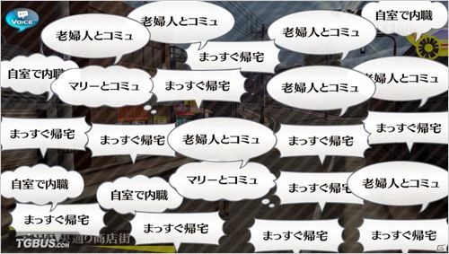
Recovery in maze
Another function of “Voice” is recovery in a maze. When player feel difficult in the maze, they can choose to “Voice” and broadcast help information to other players. If other players agree to help, then at the beginning of next battle, players’ characters will recover a little bit depending on how many players agree to help.
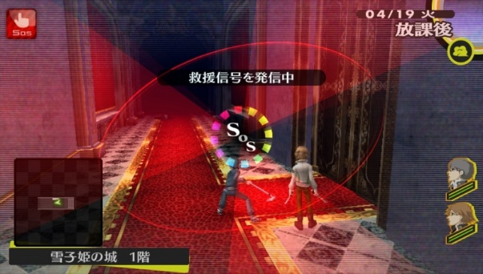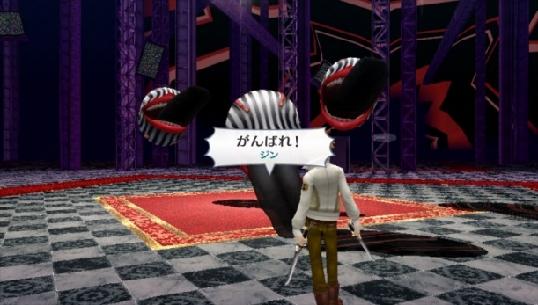
The social gameplay in P4G is a anonymous and asynchronous system. The effect is trivial but can improve players’ experience and support the game main system. This user-friendly system is a good practice about how to improve the quality of a single-player game.

Monetization
There is no monetization system in P4G since it is a pay-to-play game. But we can get some inspiration from the latest product of this series, Persona 5.
In persona 5, players can purchase outfits for their characters. And there are some bonus cards for players. Considering that there is no hard currency in these games. We cannot claim these games have monetization system. However, thanks to its designing idea of using Tarot, a monetization system based on the Persona Cards might be possible. The studio of this game is trying to sell some bundle with the sets of Persona Cards.

Why divine?
I think the gameplay style of P4G can be concluded as “Divine”. The idea is that based on a deep and complex system, designers hide the gameplay patterns and let players reveal the system by themselves. It’s not like gambling, which is a complete black box gameplay. Instead, the divine gameplay in P4G offers quite a lot biased choices for players. However, the corresponding situations with these choices are random generated and rely on players’ luck. In this way, players’ playing experience involves both the exciting moments and careful thinking.
In Battle Loop, enemies’ weak points are hidden from the beginning. But players can still deal proper attacks because the weakness attack can be made in many ways. After players became familiar with the enemies. There are still chances that enemy can deal huge damage to players, also because there are many ways to make a weakness attack.
The Daily Life Loop & Story Loop don’t have much to do with the chance gameplay. But the blind choices in the dialogues are somehow a way to convey this idea. Because the small decision will accumulate and result in bigger non-invertible consequences. Players’ choices are not completely random.
I’ve explained how the retention mechanism are “Divine” in previous parts. Overall, this gameplay is about transferring decision making action from a probability-based to strategies-based.
In what aspects are diving better that gambling? First is that divining give players more power in the game. Whenever they face new situations, they can have some simple strategies. These strategies have a considerable chance to work. So, players will be confident even they must confront new dangers. Second is that divining creates more variety in games. Based on well-structured rule sets, there are exponentially increasing number of combination that might emerge in the gameplay.
The disadvantages of divine gameplay are the difficulty tuning. If the game is not tested and tuned good enough, there are high chances that the game is hard to learn. On the developer side, the designing contents will increase dramatically if they want to make a gradual improving experience for players.

Because I didn’t mention the monetization part due to the genre specified problem. I want to add some contents on monetization about another game on mobile platform. Please feel free to ignore or read this part.

Monetization of Girl’s Frontline

Like Kentai Collection and Warship Girls, Girl’s frontline is another military theme ACG game. There are 4 soft currencies: Labor, Ammo, Rations, Gears. And one hard currency: Diamond. Here is a simple description of what the two currencies can do in the game. (Units are dolls in the game that morphed into distinguish characters)
- Soft Currencies: Battle, Manufacturing new units/equipment, Repairing damaged units, Upgrade units/equipment
- Hard Currency: Purchase resources (soft currencies), Purchase items (normal and special), Expand Inventory.
The soft currencies can be gained though daily quests, and marching quests. Hard currency is gained either by paying or festival/monthly gifts.
We can simply put it this way: soft currency supports main gameplay activities, hard currency supports VIP privileges, which is no different from many other mobile games. These VIP privileges include: Expanded inventory and team, dormitory; Unlocked characters’ new illustration and dialogues. Speed-up construction. The detailed descriptions are as follows:
- Expanded inventory, team, factory construction, dormitory: The inventory expansion is necessary for most of the players. And players often choose to use gift diamonds to purchase these expansions. Team is less important than inventory, but it is also very useful if player wants to settle in this game. Factory construction is even less important because the basic is enough for mid-level players. Dormitory are designed for high-paying players because they gain extra decorations to the dolls in the game.
- Unlocked characters’ new illustration and dialogues: To make it simple, this means new outfits for the dolls or a “marriage” with the dolls. Still this is for those players who have stronger emotional bond to the dolls. Besides these items have a social effect when players attempt to show off.
- Speed-up construction: This refers to purchasing resources or items that are necessary in gameplay. If players ran out of resources and eager to gain more, they will choose to buy these things. In fact, for players who devote time to the game every day and no more other activities, there is no solid need to purchase for these privileges. However, if some players want to gamble for increase collection, this purchase may become significant.

Overall, such ACG games encourage more purchasing on the new illustration and dialogues of dolls, which is very common among its target users. For even higher purchasing players, the hard currencies can be used for collection. To guarantee the free players’ involvement, Girls’ Frontline tunes the numerical values for some popular dolls that can be easily collected, and make these dolls necessary in the gameplay. While for these who require higher rate of collection, the illustration become a more important factor to encourage purchasing.

